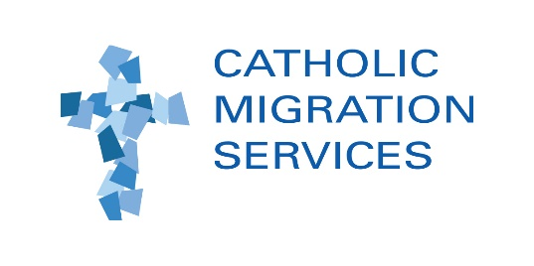

JOB ANNOUNCEMENT

PARALEGAL – TENANT ADVOCACY AND WORKERS’ RIGHTS

Catholic Migration Services (“CMS”), a nonprofit provider of legal services for low and moderate income residents of Queens and Brooklyn, is seeking a full-time bilingual (English-Spanish) paralegal for our Sunnyside, Queens office.
Position:
The paralegal will support the work of our Tenant Advocacy Program (TAP) and Workers’ Rights Program (WRP). TAP provides low-income tenants with legal advice and representation in a wide range of matters, such as eviction defense, rent overcharges, rent increase exemption applications for seniors and the disabled (SCRIE and DRIE), obtaining repairs and combatting landlord harassment. WRP provides low-wage workers with advice and representation on a wide range of employment matters, including wage theft, discrimination, unemployment insurance, paid leave and workplace injuries. WRP and TAP attorneys also conduct Know-Your-Rights presentations and participate in other community events.
The TAP team consists of four attorneys, four tenant organizers, and the paralegal. The WRP team consists of three attorneys. This is for a full-time position in our Sunnyside, Queens office, but the paralegal may be required to work off-site at other locations primarily within Queens – e.g., at client meetings, community events, and at the courthouses. Travel to other locations within New York City also may occur periodically.

Essential Duties and Responsibilities:
- Conducting intake meetings with clients and potential clients to gather information and assist CMS attorneys in assessing potential legal claims;
- Preparing applications for senior citizen rent increase exemptions (SCRIE) and disability rent increase exemptions (DRIE) under supervision of CMS attorneys;
- Copying, scanning, and otherwise assisting attorneys in the preparation of court filings, administrative agency filings, and maintaining case files;
- Communicating with clients about the status of their cases, including gathering information about the status of the tenants’ desired repairs;
- Interpreting CMS attorney-client communications and translating documents from English to Spanish, and Spanish to English;
- Data entry in CMS’ client database to keep CMS client records updated;
- Filing legal papers with courts and administrative agencies;
- Serving legal papers on landlords, employers and witnesses;
- Participating in TAP, WRP and CMS meetings;
- Assisting at outreach and educational events; and
- Providing additional support as needed.

Qualifications:
- Prior or related experience, or a Bachelor’s or Associate’s degree, preferred;
- Demonstrated commitment to public interest work;
- Excellent written and oral communication skills;
- Fluency in written and oral Spanish required;
- Excellent organizational and time-management skills;
- Basic computer skills;
- Demonstrated ability to take initiative and work independently; and
- Ability to work as part of a team.
CMS is an Equal Opportunity Employer and we welcome candidates from diverse backgrounds. Salary is commensurate with experience. CMS offers a competitive benefits package that includes a pension plan, health and dental insurance, commuter benefits and other benefits.

Application Instructions:
Applications will be accepted immediately and will be considered on a rolling basis. Interested applicants should send a cover letter, resume, and a list of at least two professional references to: Magdalena Barbosa, Managing Attorney, at mbarbosa@catholicmigration.org. Please include “Paralegal Application” in the subject line.

